Technical Design Document: Hinglish Podcast Generator
Project Name: Doc-to-Hinglish Podcast Pipeline
Version: 1.0
Date: December 30, 2025
Track Selected: Generative AI & Content Automation

Contents
Technical Design Document: Hinglish Podcast Generator 1
1. Project Overview 3
1.1 Executive Summary 3
1.2 Problem Statement 3
1.3 Key Features 3
2. System Architecture 4
2.1 High-Level Data Flow 4
2.2 Component Description 6
3. Code Explanations and Implementation Details 7
3.1 Text Extraction Strategy 7
3.2 Prompt Engineering (The "Secret Sauce") 7
3.3 Audio Stitching Logic 7
4. Setup and Deployment Instructions 9
4.1 Prerequisites 9
4.2 Local Development Setup 9
4.3 Cloud Deployment (Streamlit Cloud) 9
requirements.txt content: 10
packages.txt content: 10
5. Assumptions and Limitations 11
5.1 Assumptions 11
5.2 Known Limitations 11
5.3 Future Improvements 11
5.4 Resources 11

1. Project Overview

1.1 Executive Summary
The Hinglish Podcast Generator is an end-to-end GenAI pipeline that transforms static text content (Wikipedia articles, PDF documents, Word docs, and Images) into an engaging, 2-minute audio podcast. The system uses Large Language Models (LLMs) to rewrite factual content into a natural, colloquial conversation between two personas ("Rahul" and "Priya") in Hinglish (a blend of Hindi and English). It then utilizes Neural Text-to-Speech (TTS) engines to synthesize realistic voices, stitching them together into a seamless audio file.

1.2 Problem Statement
Users often find consuming long-form content (articles, documentation) tedious. Standard TTS readers are robotic and lack engagement. There is a need for a tool that converts dry information into an entertainment-focused format (like a casual conversation) in a localized language (Hinglish) to increase information retention.

1.3 Key Features
- Multi-Modal Input: Accepts Wikipedia topics, PDF files, DOCX files, and Images (OCR via Vision).
- Contextual Scripting: Uses GPT-4o to generate culturally relevant "Hinglish" dialogue with humor and fillers.
- Dual-Speaker Audio: distinct voices for two characters using OpenAI TTS-1.
- Audio Post-Processing: Automated mixing and timing control using pydub and FFmpeg.

2. System Architecture

2.1 High-Level Data Flow
The system follows a linear pipeline architecture: Input → Processing → Synthesis → Output.
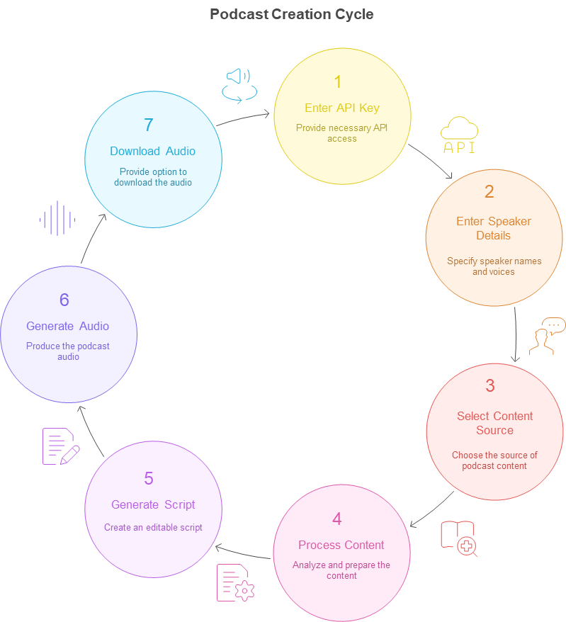
Flowchart
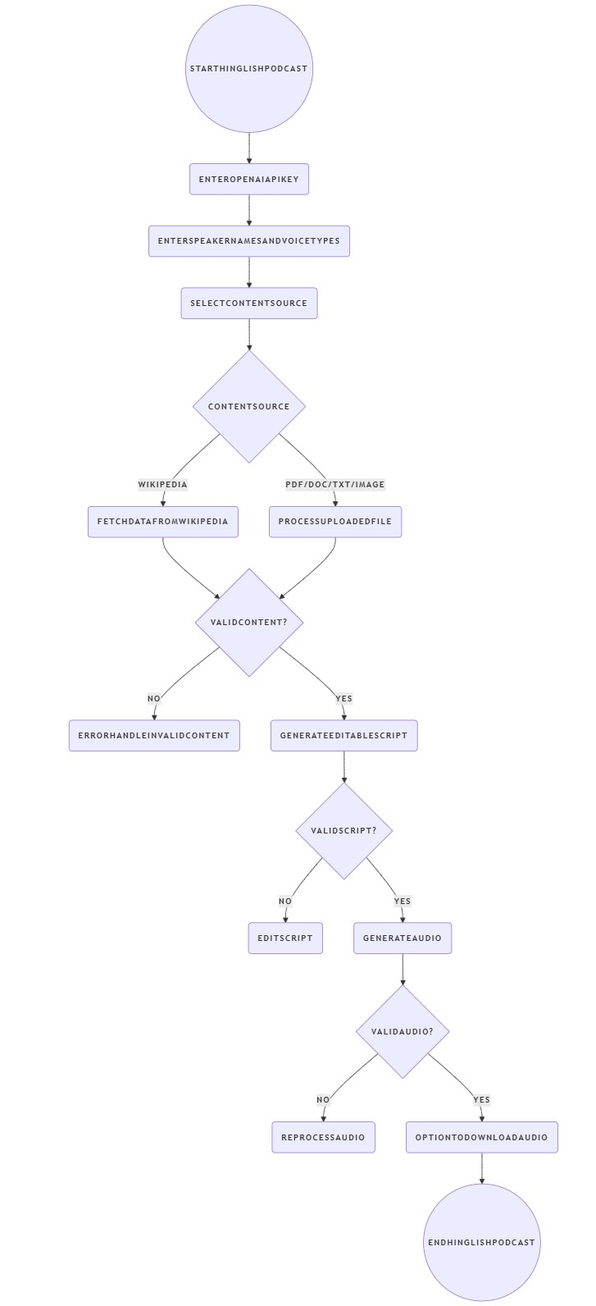

2.2 Component Description
- Frontend (Streamlit): Handles file uploads, user inputs, and plays back the final audio.
- Ingestion Layer:
  - Wikipedia: Fetches summaries via the wikipedia library.
  - Documents: Parses binary formats (.pdf, .docx) into plain text strings.
  - Vision: Converts image data to Base64 and sends to OpenAI Vision model for description.
- LLM Orchestrator:
  - Constructs a system prompt defining the "Hinglish" dialect, personas, and formatting constraints.
- Audio Engine:
  - Parses the text script line-by-line.
  - Calls the TTS API asynchronously (simulated via loop).
  - Manages audio buffers (BytesIO) to prevent disk I/O overhead.

3. Code Explanations and Implementation Details

3.1 Text Extraction Strategy
We employ a modular approach to text extraction.
- PDFs: We use pypdf to iterate through pages. We limit extraction to the first 10 pages to manage token usage and latency.
- Images: We do not use traditional OCR (like Tesseract). Instead, we use GPT-4o Vision, which provides semantic understanding of the image (e.g., explaining a diagram) rather than just raw text.

3.2 Prompt Engineering (The "Secret Sauce")
The core logic relies on a specific prompt structure to enforce the output format:
- Role: "Scriptwriter for a funny Indian podcast."
- Constraint 1 (Language): "Hinglish (Hindi + English)."
- Constraint 2 (Fillers): "Use 'Arre yaar', 'Achcha', 'Matlab'." (Crucial for natural-sounding TTS).
- Constraint 3 (Formatting): "Name: Dialogue" (Used for Regex parsing later).

3.3 Audio Stitching Logic
The generate_audio function is the most computationally intensive part.
Code Python

# Simplified Logic Representation
combined_audio = AudioSegment.empty()
for line in script:
if "Rahul" in line:
audio_chunk = api_call(voice="onyx", text=line)
elif "Priya" in line:
audio_chunk = api_call(voice="nova", text=line)

# 150ms silence added for conversational pacing
combined_audio += audio_chunk + AudioSegment.silent(duration=150)
- Assumption: The TTS API latency is low enough that sequential processing doesn't cause a timeout.
- Library: pydub is used because it handles MP3 headers and concatenations seamlessly.

4. Setup and Deployment Instructions

4.1 Prerequisites
- Python: Version 3.9 - 3.11 (Preferred).
- FFmpeg: System-level dependency for audio processing.
- API Key: Valid OpenAI API key with Credits (not just free tier).

4.2 Local Development Setup
- Clone/Create Directory:
Code Bash
mkdir podcast-gen && cd podcast-gen
- Install FFmpeg:
  - Mac: brew install ffmpeg
  - Windows: Download binaries and add to PATH.
  - Linux: sudo apt install ffmpeg
- Install Python Libraries:
Code Bash
pip install streamlit openai wikipedia pydub pypdf pillow python-docx
- Run Application:
Code Bash
streamlit run app.py

4.3 Cloud Deployment (Streamlit Cloud)
To deploy this online, the following file structure is strictly required to avoid the FileNotFound or audioop errors:
File Structure:
Code Text
/repo
├── app.py # Main application code
├── requirements.txt # Python dependencies
└── packages.txt # System dependencies (Linux)

requirements.txt content:
streamlit
openai
wikipedia
pydub
pypdf
pillow
python-docx
audioop-lts # Required if Cloud uses Python 3.13+

packages.txt content:
ffmpeg

5. Assumptions and Limitations

5.1 Assumptions
- Input Quality: The system assumes the uploaded PDF/Image contains legible text.
- Language: The input content is primarily in English (the LLM translates it to Hinglish).
- API Availability: OpenAI API status is operational.
- Audio Format: The desired output is always MP3.

5.2 Known Limitations
- Latency: Generating a 2-minute audio clip can take 30-60 seconds depending on API load.
- Cost: Using GPT-4o and TTS-1 incurs a cost (approx. $0.03 per podcast).
- Accent: While "Hinglish" text is generated, the underlying accent of OpenAI's voices is American/British. It sounds like an NRI (Non-Resident Indian) speaking.
- Token Limits: Very large PDFs (100+ pages) are truncated to the first 10 pages to fit within the LLM context window.

5.3 Future Improvements
- Indian Accents: Integration with ElevenLabs Multilingual V2 model for authentic Indian accents.
- Streaming Audio: Implement chunked streaming so audio plays immediately rather than waiting for full generation.
- Language Selection: Allow users to choose between Hinglish, Pure Hindi, or Tamil/English mix.
- Paid / Unpaid: If paid users, key input is not required and the same can be mapped at the backend.

5.4 Resources
Description | Resource
Python code for the App
Requirements Document (Libraries for import)
Packages to be used
Keys to be used
mp3 for Wikipedia Content Podcast
mp3 for Upload Document Content Podcast
mp3 for Upload Image Content Podcast
YouTube Link for Demo | https://youtu.be/NfMARHYFB1Y

